ALGORITHM FOR PERIPHERAL INTRAVENOUS CATHETER CARE

Select the appropriate site for
catheter insertion.
Select a vein in the
appropriate area.
Select the
catheter.
Select the dressing.
Care of the catheter. Evaluate the catheter
site.

Upper Extremity

Lower Extremity
- Select a comfortable zone for the patient.
- Avoid veins in areas that are irritated, red, or painful.
- Do not insert catheters into veins that feel stiff.
- Do not use the related area in cases such as mastectomy or fistula.
- Select a vein from distal to proximal of the extremities.
- Firstly, choose cephalic or basilic veins.
- Alternatively, select the metacarpal veins.
- Do not select the antecubital area.
- If you have difficulty choosing an area, use ultrasound or imaging devices.

- Do not use the lower extremities unless necessary.
- If you must use the lower extremities, use the dorsal area of the foot or the great saphenous vein in the ankle.
- Remove a catheter inserted in the lower extremity as soon as possible.
- When choosing a catheter, consider the patient's diagnosis, the type of fluid to be administered and the vein structure.
- If possible, select 20 or 22
catheters.
- Choose polyurethane catheters.
- Use transparent, semi-permeable polyurethane dressings.
- Secure the catheter so that movement is prevented.
- Do not change transparent dressings as long as the catheter remains in place.
- Change the dressing if it is damaged, soiled, or wet.
- If the patient is sweating profusely, put gauze under the dressing to absorb fluid.
- Change the gauze every 24 hours or without waiting 24 hours if it gets dirty.
- Wash your hands with soap and water before inserting the catheter.
- Wear nonsterile gloves.
- Clean the area to be operated for at least 15 seconds with 70% alcohol containing 2% chlorhexidine, 70% alcohol or povidone iodine.
- Wait until the area is completely dry before performing the procedure.
- Do not apply antimicrobial ointment to the catheter area.
- Do not obstruct arterial flow when applying a tourniquet.
- Use an extension set for the tip of the catheter.
- Record the insertion date and site of catheterization.
- Wipe the insert part of the extension sets with 70% alcohol before each application and allow them to dry.
- Flush the catheter with 5 ml 0.9% sodium chloride before and after each drug administration.
- Flush with 5 ml of 0.9% sodium chloride every 24 hours when the catheter is not in use.
- Dilute the drug with at least 100 ml of 0.9% sodium chloride according to the drug administration recommendations.
- Do not change continuous infusion sets before 96 hours unless otherwise noted.
- Change intermittent infusion sets every 24 hours.
- Change sets of blood and blood components when transfusion is complete or every 4 hours.
- Evaluate the catheter site using phlebitis and infiltration scales every 8 hours maximum.
- Evaluate the site every 1-2 hours if the
catheter is in a flexion site.
- Do not change the catheter at routine intervals if there are no problems at the catheter site.
- Evaluate catheter requirements daily.
- Remove the catheter when the catheter is no longer required.
- Remove emergency catheters within 24-48 hours and insert another catheter, if necessary.

PHLEBITIS

No Yes
Diagnose the development of a catheter complication.
  - Change parenteral nutrition solution sets every 24 hours.

INFILTRATION

No Yes

Determine the Grade of Phlebitis
Determine Grade of Infiltration

Grade 0 Grade 1 Grade 2 Grade 3 Grade 4 Grade 0 Grade 1 Grade 2 Grade 3 Grade 4

Symptoms
- No symptoms

Symptoms
- Erythema at access site with or without pain

Symptoms
- Pain at access site with erythema and/or edema

Symptoms
- Pain at access site with erythema and/or edema;
- Streak formation;
- Palpable venous cord

Symptoms
- Pain at access site with erythema and/or edema; streak formation;
- Palpable venous cord >1 in (2.5 cm) in length;
- Purulent drainage

Symptoms
- No symptoms

Symptoms
- Skin blanched
- Edema <1 in (2.5 cm) in any direction
- Cool to touch
- With or without pain

Symptoms
- Skin blanched
- Edema 1 to 6 in (2.5-15 cm) in any direction
- Cool to touch
- With or without pain.

Symptoms
- Skin blanched,
translucent
- Gross edema >6 in (15 cm) in any direction
- Cool to touch
- Mild to moderate pain
- Possible numbness

Symptoms
- Skin blanched, translucent
- Skin tight, leaking
- Skin discolored, bruised, swollen
- Gross edema >6 in (15 cm) in any direction
- Deep pitting tissue edema
- Circulatory impairment
- Moderate to severe pain
- Infiltration of any amount of blood product,
- irritant, or vesicant






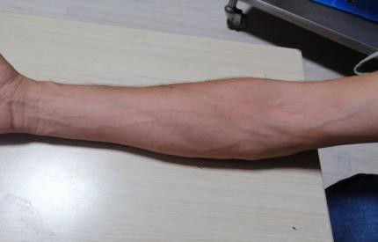
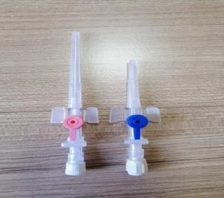
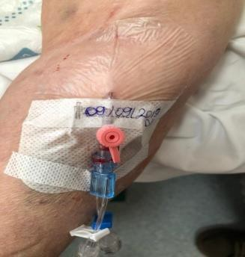
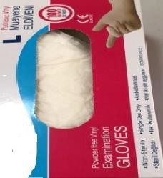












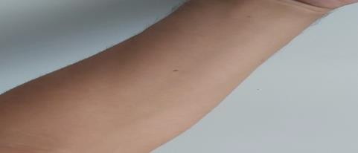

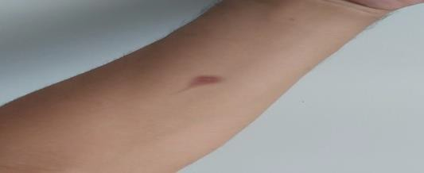
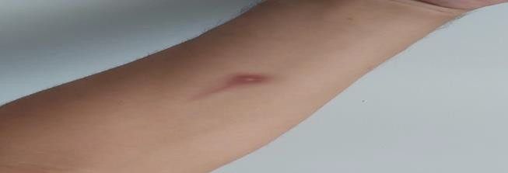
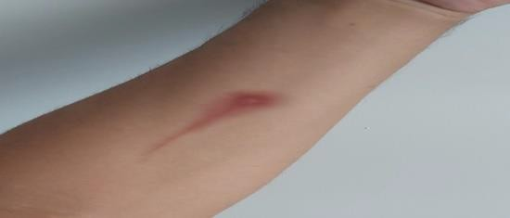
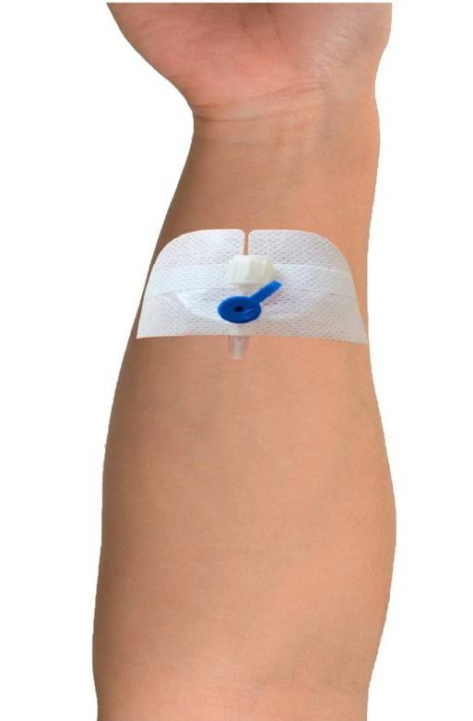
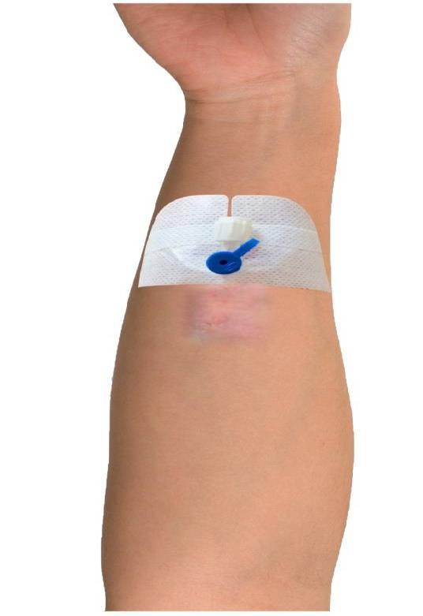
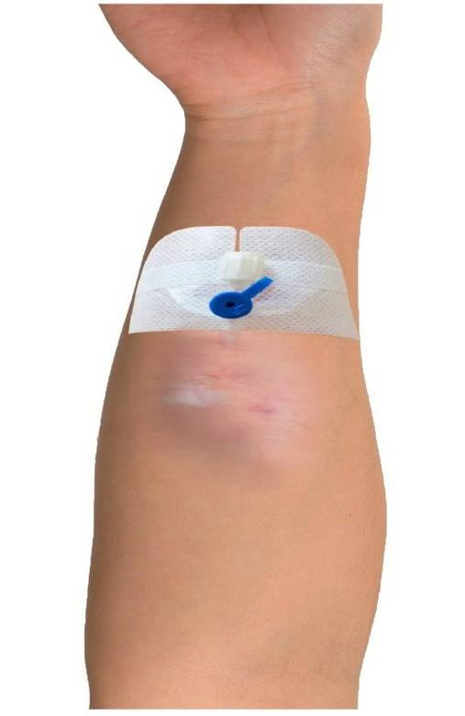
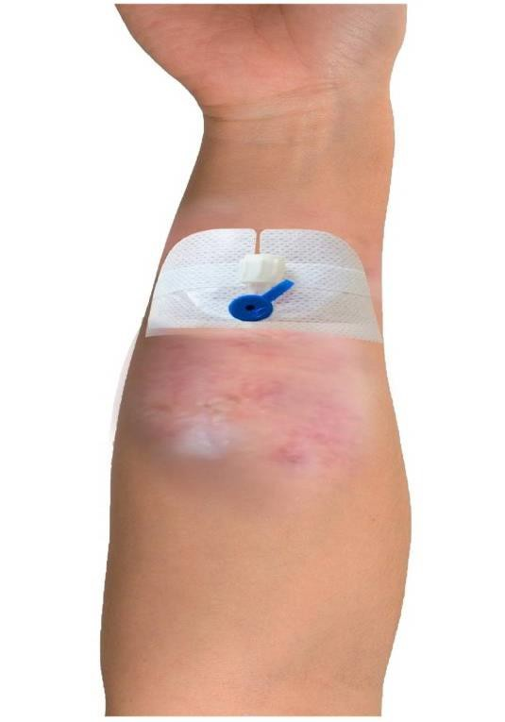
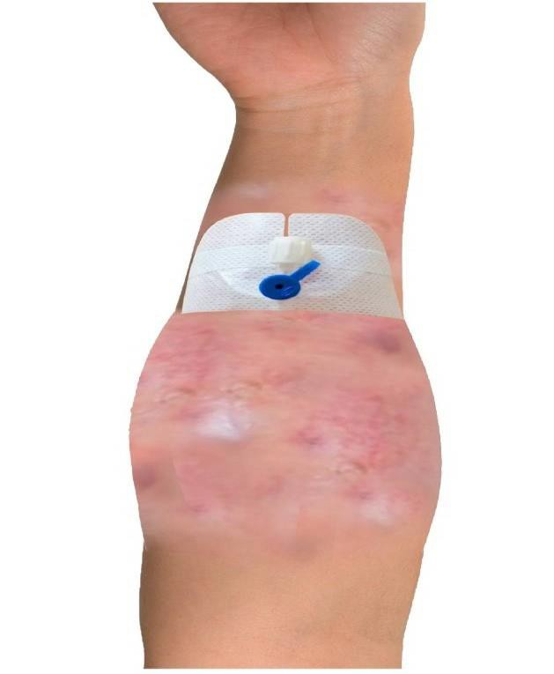
Interventions
- Return to the
evaluation phase.

Interventions
- Return to the
evaluation phase.

Interventions
- Discontinue administration of the drug or fluid.
- Remove the catheter.
- If intravenous therapy is to be continued, insert a new catheter to the other extremity.
- Elevate the affected extremity.
- Apply a warm wet compress for 20 minutes 3 times a day.
- If necessary, apply analgesic and anti-inflammatory drugs according to the physician's orders for treatment.
- Evaluate the catheter site region once every 8 hours maximum.
- Record the date of removal of the catheter, the grade of complication developed, and the interventions performed.

Interventions
- Return to the
evaluation phase.

Interventions
- Discontinue administration of the drug or fluid.
- Disconnect the administration set from the catheter, aspirate the infiltrating drug or fluid with a injektor.
- Remove the catheter.
- If intravenous therapy is to be continued, insert a new catheter to the other extremity.
- Never apply pressure to the infiltration area.
- Mark the area with a pen for evaluation of the infiltration area.
- Elevate the affected extremity.
- Apply a dry cold compress if you intend to localize the non-vesicant drug or fluid in the tissue and reduce inflammation.
- Apply a dry warm compress if you intend to restore peripheral blood flow and distribute drug or fluid into the tissue.
- Evaluate the catheter site region once every 8 hours maximum.
- Record the date of removal of the catheter, the grade of complication developed, and the interventions performed.

