Supplementary Material for:
Wright MT, Smith DE, Baird CS, Ibrahim JE. Using the Theoretical Framework of Acceptability to understand the acceptability of e-training for nurse led prevention of unwanted sexual behaviour in Australia’s residential aged care services.. Aust J Adv Nurs. 39(4):23-34. Available from: https://doi.org/10.37464/2020.394.762

Page 2: Appendix 1: Interview Questions
Page 4: Appendix 2: COREQ
Page 6: Appendix 3: Preventing Unwanted Sexual Behaviour in Residential Aged Care Services Curriculum Guide
Page 9: Appendix 4: Data sources and timeline of project
Page 11: Appendix 5: Ethics Approval
Appendix 1: Interview Questions

Total number of questions used: 7
Estimated duration of interview is 30-45 minutes
Interview questions were developed by the research team. Please note this is a draft version of the interview, minor changes may be made to the final version. This will be submitted with an ethics application pending Monash Ethics approval.
Question 1. What is your professional job title and how long have you been in your professional role in aged care?
*Trigger warning*
“The interview will involve sensitive questions surrounding unwanted sexual behaviours in residential aged care. You can choose to answer these or not. For the purpose of our interview, I’d like to define unwanted sexual behaviours as an umbrella term that includes a wide range of sexual contact and non-contact acts, which may or may not constitute illegal behaviour. The term can include penetration, unwelcome sexualised conversation or jokes, unwanted touching, and threats to commit a sexual offence. Do you understand? Are you happy to continue with this interview?”
Question 2. “What inspired you to take the short course we offered?”
Question 3. Before taking this course, how confident did you feel responding to incidents of unwanted sexual behaviour?
Question 3b. After taking this course, how confident do you feel responding to incidents of unwanted sexual behaviour?
If NOT CONFIDENT | If CONFIDENT
a. Prompt: What areas do you feel more confident in? (e.g. detecting, managing, preventing, unwanted sexual behaviour?) | a. Prompt: (If confident) did you find the content interesting/useful?
b. Prompt: If not, why? | b. Prompt: Have you gained any new methods to prevent unwanted sexual behaviour occurring?
Question 4. Since undertaking the short course, have you changed or considered changing your current practice?
If YES | If NO
a. Prompt: If so, how? | a. Prompt: If not, do you believe the current standard of aged care nurse training and education is adequate?  b. Prompt: Do you think further training and education regarding unwanted sexual behaviours in aged care should be mandatory? To who?
Question 5a. How, or in what way was short course content relevant and practical to your professional role in aged care? What about your colleagues?
Question 5b. What changes would you suggest we make so the course is more suitable for personal care workers?
If YES | If NO
a. Prompt: If so, what module/topic was the most relevant/useful to you? | a. Prompt: If not, why?
b. Prompt: Please give examples. | b. Prompt: If not, do you believe personal care workers would be interested in taking the short course?
Question 6. Overall how satisfied were you with the course?
Prompts:
a. What topics do you believe the course covers well?
b. What was the most memorable part of the course?
c. What did you like least about the course?
d. Would you recommend other people to do this course? Who?
e. How could this course be improved?
Question 7. We have now completed our interview questions, is there anything else you wish to say?
If YES | If NO
- Prompt: do you believe covid impacted your ability to complete the course? How did covid impact your workplace?  - b. Prompt: Any further comments on USB in aged care or aged care more generally? | a. End interview
For Interviewer Only
Question | Purpose
1 | Introduction
2 | Short course e-learning and training program evaluation
3 | Participant behaviour PRE/POST intervention:
4 | Transfer and application of knowledge gained from short course
5 | Relevance of online course content to aged care staff
6 | Satisfaction with online course
7 | Open invitation for participant to discuss any topic they wish
Appendix 2. COREQ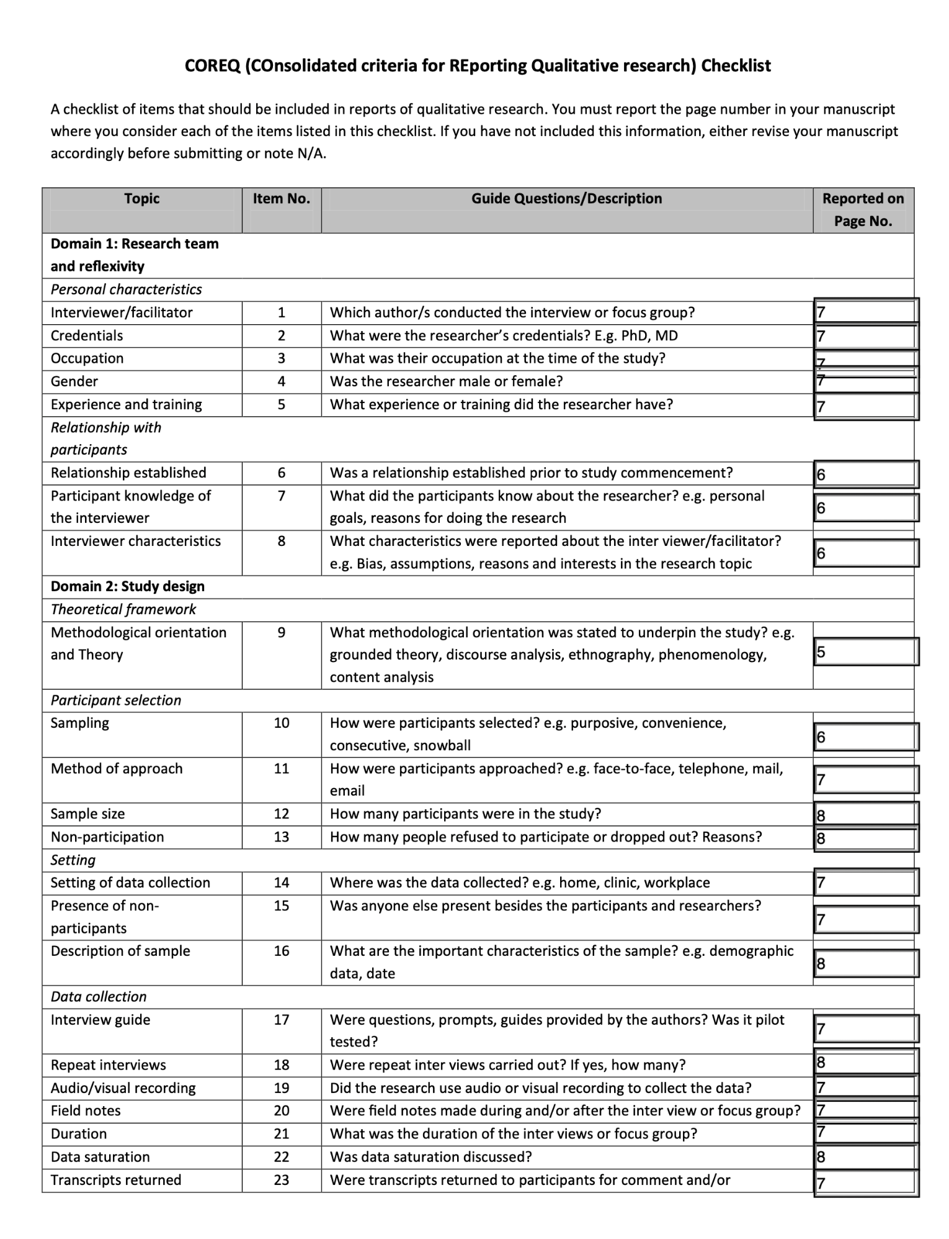
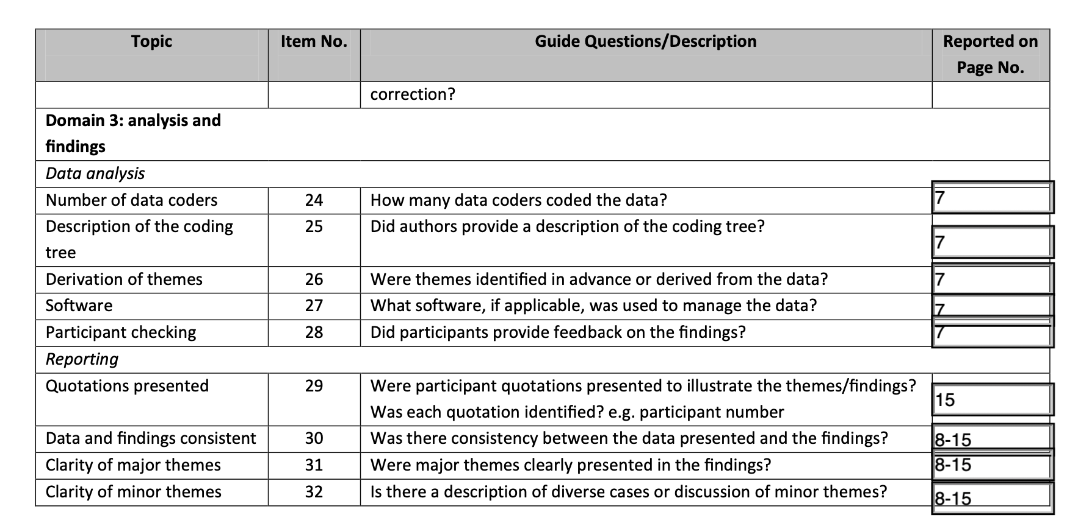
Appendix 3. Preventing Unwanted Sexual Behaviour in Residential Aged Care Services Curriculum Guide

‘Preventing Unwanted Sexual Behaviour in Residential Aged Care Services’ Curriculum Guide
Course overview
Content was based on the jurisdictional criminal laws in Victoria and the regulatory and administrative frameworks of the Commonwealth of Australia.
Course themes
Course content addressed four themes of USB in RAC: (i) detection; (ii) management (iii) prevention and (iv) handling and disclosing information. The course included recommended direction and actions to be taken by RAC nursing staff when USB is (i) suspected; (ii) witnessed and; (iii) disclosed. The course intended to prompt aged care nursing staff to provide timely, appropriate and empowering responses to incidents occurring in their RAC facility.
Module 1-5 Overview
Module 1 – Defining Unwanted Sexual Behaviour
Identify misconceptions about older people’s sexual expression and experience of USB
Define USB and understand how different sub-categories are determined
Define and identify Commonwealth of Australia criteria for ‘reportable incidents’ of USB in RACS and introduce Serious Incident Response Scheme changes
Module 2 – Identifying Characteristics of Unwanted Sexual Behaviour
Describe and identify common risk factors for the occurrence of USB in RACS
Understand how USB presents, impacts and could be prevented in persons with cognitive impairment in RAC.
Identify the major barriers to detecting and prosecuting incidents of USB in RAC.
Module 3 – Detection, Management and Support in Incidents of Unwanted Sexual Behaviour
Identify physical, emotional, psychological and behavioural indicators of experience USB in RAC.
Identify management techniques of suspected, witnessed or disclosed incidents of USB (listening, talking and responding to victim-survivors; documenting incidents, aiding investigations (e.g. preserving forensic evidence, liaising with external support services).
Explore incident management techniques for target’s who are cognitively impaired.
Review documentation requirements for incidents of USB in RAC and legal investigations.
Module 4 – Managing Resident Exhibitors and Prevention Strategies of Unwanted Sexual Behaviour
Identify techniques to manage residents who are exhibitors of USB
Identify techniques for monitoring sexual expression in residents
Identify strategies for preventing a resident engaging in USB.
Module 5 – Handling and Disclosing Information Concerning Unwanted Sexual Behaviour
Define and describe information that is. personal, private and confidential
Understand the privacy and confidentiality obligations for aged care staff and others when managing incidents of USB (e.g. resident’s family, other health professionals, police etc.)
Review and understand the role of substitute decision makers during incidents of USB in RAC.
Case study and Zoom webinar
A hypothetical case study of Mrs S, a female RAC resident with mild dementia and other health conditions, who alleged rape was presented. Incident information presented in a logical flow, with information revealed over time, pausing to ask questions specific to the content known. It was recommended that participants complete all modules before reading the case study. The case study was presented in a logical sequence along with questions corresponding to content presented in modules 1-5. Answers were provided to participants at the end of course completion via an optional Zoom webinar activity. The case study and webinar intended to facilitate learning and test understanding of course content. It also intended to be an opportunity for participants to apply knowledge and reflect on how they would manage this, or a similar, incident occurring at their RAC facility and to ask any unanswered questions.
Online Discussion Forum
Hosted via Moodle and available during the 2-week enrolment into the course and moderated by two members of the research team. Involvement was left to participant discretion, although the research team recommended spending 10-15 minutes, once or twice a week, in order for participants to generate and engage in self-directed discussion and reflection on the subject matter

Appendix 4. Data sources and timeline of project
Study phase | Date | Data source & collection strategies | Participant numbers | Participant used in this study
Pre-intervention survey | August - September 2020 | Online survey using Qualtrics to test participants pre-intervention knowledge, attitudes awareness, experience of and behaviour towards USB in RACS (n=14) | 46 participants | No
Intervention | September - October 2020 | N/A  The purpose of this phase was to implement the e-learning intervention. Course content was developed to offer guidance on detection, management, responding and prevention of USB in RACS) | 45 participants | No
Zoom webinar | October 2020 | N/A  The purpose of this phase was to offer a virtual “face-to-face” component to consolidate learning and review the end-of-course case study. Participants were also encouraged to ask any questions regarding course content and informally offer feedback. | 18 webinar attendees | No
Post-intervention survey | October - November 2020 | Online survey using Qualtrics to test participants pre-intervention knowledge, attitudes awareness, experience of and behaviour towards USB in RACS (n=23). Survey also had a course evaluation items block (n=15 items). | 38 participants | Yes, selected from this group
Telephone interviews | November - December 2020 | Qualitative semi-structured telephone interviews with participants who had partially or completed the intervention conducted two weeks after intervention end date. Interviews consisted of 9 interview items. | 18 participants | Yes
Analysis of Interviews | April – October 2021 | Of the participants interviewed, only 17 of them qualified. One was excluded because although they had completed the post-intervention survey, they had not completed the intervention. | 17 | Yes

Appendix 5. Ethics Approval
